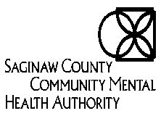
Network Clinician Application for Credentialing and Privileging for Applied Behavioral Analysis (ABA) staff
Updated 7/25/22
As a Clinician/ Staff within Saginaw County Community Mental Health’s (SCCMHA) Network it is required that an application be completed for each professional licensed staff providing and billing for services to individuals within our network. Below application for credentialing and privileging, along with related attachments. Please complete the sections according to each position’s title requirements.
Furthermore, ABA Providers are required to submit the following information for all Behavioral Technicians (BT): hire date, background checks (criminal background check, MDOC, Sex Offender, DHHS Central Registry Check), sanction checks (MI Provider Sanction List, Office of Inspector General [OIG], SAM- these must be completed monthly as well), BT training, first aid/CPR, blood borne pathogens and infection control training, proof of ABA plan review, proof of IPOS plan review, verification of education, driver license, National Provider Identifier (NPI) and supervising BCBA or other professional (BCaBA, LP, LLP or QBHP) overseeing the behavioral plan of care. Behavioral Technicians do not need to complete the below credentialing application at this time. However, all documents listed above are expected to be submitted to SCCMHA credentialing@sccmha.org for review prior to any services being rendered to Saginaw consumers.
The following credentialing application is required to be completed for all ABA supervisors, which includes LP, LLP, QBHP’s, BCaBA’s, and BCBA’s. ABA providers are also required to submit applications for OT, PT, Speech, and Recreational Therapists. Applications must be accompanied with proof documents to support the credential listed. The following listed documents are required to be provided with the credentialing application for the ABA supervisors also. These documents are expected to be submitted to the credentialing@sccmha.org for review prior to any services being rendered to Saginaw consumers.
The following qualifications must be demonstrated in your application materials in order for us to accept your application:
- License: A current unrestricted, unconditional license to practice mental health and/or substance use disorder services in the State of Michigan;
- Certification (if applicable): Current certifications to provide specialized services as required by the State of Michigan;
- Sanction Checks (OIG, SAM, State of Michigan [MI] Sanction Report) or if you use a company please make sure these listed are minimally a part of the check; these checks must be completed monthly as well
- Department of Health and Human Services (DHHS) Central Registry Check without any concerns
- National Practitioner Data Bank (NPDB) check
- Enrollment in CHAMPS
- Criminal background check prior to hire and every 2 years during employment with the Provider.
- Every 2 years clinician/ staff are required to complete this application for re-credentialing purposes.
The application and attachments may be filled out electronically and scanned to email credentialing@sccmha.org. Please print, date, and sign the application with required attachments, when submitting for approval.
Section A: Staff Information-New Credentialing / Re-credentialing (attach copies)
Name (Last, First, Middle): |  |  | Today’s Date:
Other Names Used: |  |  | Email:
Position Title: |  |  | Date of Hire:
Organization Name: |  |  | Date of Birth:
Home Address: | State: | Zip: | License Type:
City: | Fax: |  | License #:
Phone: |  |  | Date of CPR and First Aid:
Gender: Choose an item. If Other: |  |  | Ethnicity: Choose an item. If Other:
Board Certified: Yes No |  |  | Provide Direct Services: Yes No
National Provider Identifier (NPI): |  |  | Taxonomy Code:
Initial Background Check: |  |  | Ongoing Background Check:
Sanction Checks (OIG, SAM, Sanction Report): |  |  | NPDB Check:
Supervise Staff: Yes No |  |  | Supervision occurring by (for ABA/TLLP only):
Please specify all fluent communicable languages, including sign language: Choose an item. If Other:
For your convenience, a checklist has been included on page 6 of the application to ensure you have attached all required documents for the application to be accepted. Please note: Failure to complete all required sections will result in the application being denied and returned for completion. Please submit proof documentation for each credential type.

Section B: Valid Certifications/Licenses (attach current copies) Please see acronym definitions on pg. 7.
License/Certification:
☐BCBA | ☐BCaBA |  | ☐CCC-SLP |  | ☐CHES |  |  | ☐CHW |  |  | ☐CMHP |  |  | ☐LBSW | ☐LLBSW |  | ☐LLMFT
☐LMFT | ☐LLMSW |  | ☐LLPC |  | ☐LPC |  |  | ☐LLP |  |  | ☐LP |  |  | ☐OTRL | ☐OTR |  | ☐PSS
☐PTA  ☐SLP | ☐PTL  ☐TLLP |  | ☐QBHP |  | ☐QIDP |  |  | ☐QLP |  |  | ☐QMHP |  |  | ☐RBT ☐RD ☐RPT  ☐ Other
Indicate all past and current licenses and certifications.
Certification/License Type |  |  |  |  |  |  |  |  | State/  Province |  |  | Number |  |  |  | Expiration Date
Section C: Privileges, Licensure, and Malpractice History –
Attach documentation to support selections and yes responses below.
Privileges/Certifications:
☐ Board Certified Behavioral Analyst (BCBA)
☐ Board Certified Assistant Behavioral Analyst (BCaBA)
☐ Certified Mental Health Professional (CMHP)
☐ Dialectical Behavior Therapy (DBT)
☐ Dimensions Tobacco Free Program
☐ Family Psychoeducation (FPE)
☐ INDEPTH (Intervention for Nicotine Dependence: Education, Prevention, Tobacco and Health)
☐ Parenting Through Change (PTC)
☐ Parenting Through Change-Reunification (PTC-R)
☐ Parent Management Training Oregon Model (PMTO)
☐ Parenting With Love and Limits (PLL)
☐ Parenting Wisely (PW)
☐ Parent Support Partner (PSP)
☐ Qualified Behavioral Health Professional (QBHP)
☐ Qualified Intellectual Disability Professional (QIDP)
☐ Qualified Licensed Practitioner (QLP)
☐ Qualified Mental Health Professional (QMHP)
☐ Strengthening Families
☐ Trauma Focused Cognitive Behavior Therapy (TF-CBT)
☐ Trauma Recovery Empowerment Model (TREM) (Specify versions below)
☐ Whole Health Action Management (WHAM)
☐ Youth Peer Support Specialist
☐ Other

- Have you ever been dismissed from a hospital or behavioral healthcare organization staff? ☐Yes ☐ No
- Have you ever had a hospital initiate suspension, restriction, dismissal or been refused or ☐ Yes ☐ No
denied privileges?
- Have you ever voluntarily surrendered any privileges? ☐Yes ☐ No
- Have you ever surrendered privileges upon threat of censure, restriction, suspension, or revocation of privileges?
☐ Yes ☐ No
- Have any of your licenses or certifications been suspended, revoked, placed on probation or conditional status,
restricted, or voluntarily surrendered? ☐Yes ☐ No
- Is any action currently pending to suspend, revoke, or restrict any of your licenses or certifications?
☐ Yes ☐ No
- Have you been subject to any disciplinary proceedings by any local, state, or national professional organization?
☐ Yes ☐ No
- Have any malpractice claims ever been filed against you, or to the best of your knowledge, are there any claims currently pending in regard to the practice of mental health or substance use treatment? ☐ Yes ☐ No
- Have any malpractice allegations involving your work been settled by you or your carrier prior to the filing of a claim?
☐ Yes ☐ No
- Have you ever been denied professional liability insurance, had your insurance cancelled, or your renewal denied? ☐Yes ☐ No
- Have you ever been a defendant in any lawsuit in regard to the practice of health or substance use treatment?
☐ Yes ☐ No
- Have you ever been convicted of a felony? ☐ Yes ☐ No
- If yes to felony question #12 when? and for what?
Click or tap here to enter text.

- You must provide, at minimum, the prior 5 year’s history of any professional liability claims
resulting in a judgement or settlement. If applicable complete attachment - Professional Liability Action Detail
Attached ☐ N/ A ☐
- Have you previously had any affiliation either by contract or employment with another Community Mental Health in Michigan? ☐ Yes ☐ No
If so, list the CMH here: Click or tap here to enter text.

Section D: Statement of Ability to Perform
- Do you now, or have you had any physical condition, mental condition, or substance abuse condition (alcohol, illegal or prescription drugs) that has interfered with your ability to practice or perform clinical duties, or led to suspension, termination, or any other disciplinary action? ☐ Yes ☐ No
- Are you currently engaged in the illegal use of controlled substances? ☐ Yes ☐ No
- Are you licensed to provide services to children and adolescents? ☐ Yes ☐ No
- Are you licensed to provide services to adults? ☐ Yes ☐ No

Services you wish to provide (Behavior services, behavior technician, occupational therapy, speech therapy, physical therapy, dietary services):
Click or tap here to enter text.
Application Checklist
The following items are required:

☐ All applicable items on the application are complete and legible

☐ Copy of valid picture identification issued by a state or federal agency (e.g. driver’s license or passport)

☐ Copy of official transcript for your highest degree earned (verification required)

☐ Copy of highest degree earned

☐ Copy of all current licenses and certifications to support services you wish to bill

☐ Copy of current CV/Resume

☐ Copy of initial and ongoing background check

☐ Copy of the National Practitioner Data Bank (NPDB) check (if newly licensed not necessary for initial credentialing will be necessary for staff at recredentialing) Please note date of graduation/completion of certification and date of licensed issued to justify no NPDB check.

If unable to provide, please submit the following:
- Minimum five-year history of Professional Liability.
- Disciplinary Status with regulatory board or agency
- Medicare/Medicaid sanctions

☐ Copy of sanctions checks completed: SAM, MI, OIG, LEIE, etc. (These will need to be completed monthly)

☐ Copy of all trainings/certificates to support requested privileges

☐ Copy of Recipient Rights Check for all counties worked in

☐ Copy of DHHS Central Registry Check

☐ Copy of NPI

☐ Copy of Taxonomy Code

Submitted by: _______________________________________ Date: ________________

Credential and Licensure Definitions

- BCBA: Board Certified Behavior Analyst
- BCaBA: Board Certified Assistant Behavior Analyst
- CCC-SLP: Certificate of Clinical Competence in Speech-Language Pathology
- CHES: Certified Health Education Specialist
- CHW: Community Health Worker
- CMHP: Certified Mental Health Professional
- LBSW: Licensed Bachelor Social Worker
- LLBSW: Limited License Bachelor Social Worker
- LLMFT: Limited Licensed Marriage Family Therapist
- LMFT: Licensed Marriage Family Therapist
- LLMSW: Limited Licensed Master Social Worker
- LMSW: Licensed Master Social Worker
- LLPC: Limited Licensed Professional Counselor
- LPC: Licensed Professional Counselor
- LLP: Limited License Psychologist
- LP: Licensed Psychologist
- OTRL: Occupational Therapist Registered License
- OTR: Occupational Therapist Registered
- PTA: Physical Therapist Assistant
- PTL: Physical Therapist License
- QBHP: Qualified Behavioral Health Professional
- QIDP: Qualified Intellectual Disability Professional
- QLP: Qualified Licensed Practitioner
- QMHP: Qualified Mental Health Professional
- RBT: Registered Behavioral Technician
- RD: Registered Dietician
- RPT: Registered Play Therapist
- SLP: Speech Language Pathologist
- TLLP: Temporary Limited License Psychologist

CMHP- Child Mental Health Professional -Individual with specialized training** and one year of experience in the examination, evaluation, and treatment of minors and their families and who is a physician, psychologist, licensed or limited-licensed master’s social worker, licensed or limited-licensed professional counselor, licensed or limited-licensed marriage and family therapist or registered nurse; or an individual with at least a bachelor’s degree in a mental health related field from an accredited school who is trained and has three years supervised experience in the examination, evaluation, and treatment of minors and their families; or an individual with at least a master’s degree in a mental health-related field from an accredited school who is trained and has one year of experience in the examination, evaluation and treatment of minors and their families. For the BHT/ABA services individuals must be a BCBA or BCaBA or Psychologist working within their scope of practice with extensive knowledge and training on behavior analysis and BCBA certified by 9/30/2020.

QBHP- Qualified Behavioral Health Professional- a QBHP must be certified within two years of successfully completing their ABA graduate coursework or by 9/30/2025 whichever is the shorter time period. Must be a physician or licensed practitioner (e.g. Advanced Practice RN, Psychologist, Clinical Social Worker, Physician Assistant, etc.) with specialized training and one year of experience in the examination, evaluation, and treatment of children with ASD. Or, hold a minimum of a master’s degree in a mental health-related field or a BACB approved degree category from an accredited institution who is trained and has one year of experience in the examination, evaluation, and treatment of children with ASD. Works within their scope of practice and have extensive knowledge and training in behavior analysis. Extensive knowledge is defined as having taken documented course work at the graduate level at an accredited university in at least three of the six following areas: 1. Ethical considerations. 2. Definitions & characteristics and principles, processes & concepts of behavior. 3. Behavioral assessment and selecting interventions outcomes and strategies. 4. Experimental evaluation of interventions. 5. Measurement of behavior and developing and interpreting behavioral data. 6. Behavioral change procedures and systems supports.

QIDP- Qualified Intellectual Disability Professional- Individual with specialized training*(including fieldwork and/or internships associated with the academic curriculum where the student works directly with persons with intellectual or developmental disabilities as part of that experience) OR one year of experience in treating or working with a person who has intellectual disability; AND is a psychologist, physician, educator with a degree in education from an accredited program, social worker, physical therapist, occupational therapist, speech-language pathologist, audiologist, behavior analyst, registered nurse, registered dietician, therapeutic recreation specialist, a licensed/limited-licensed professional counselor, OR a human services professional with at least a bachelor’s degree in a human services field.

QMHP- Qualified Mental Health Professional- Individual with specialized training** (including fieldwork and/or internships associated with the academic curriculum where the student works directly with persons receiving mental health services as part of that experience) OR one year of experience in treating or working with a person who has mental illness; AND is a psychologist, physician, educator with a degree in education from an accredited program, social worker, physical therapist, occupational therapist, speech-language pathologist, audiologist, behavior analyst, registered nurse, therapeutic recreation specialist, licensed/limited-licensed professional counselor, licensed or limited licensed marriage and family therapist, a licensed physician’s assistant, OR a human services professional with at least a bachelor’s degree in a human services field.

^1 Complete reporting and service requirements are determined by the Medicaid Provider Manual, HCPCS and CPT codes. CPT codes, descriptions, and two-digit modifiers only are Copyright American
Medical Association. All rights reserved.
*2 Evidence of specialized training would include fieldwork and/or internships associated with the academic curriculum where the student works directly with individuals with intellectual or developmental
disabilities as part of that experience. The time spent in fieldwork or internship can be counted toward the one-year experience requirement and must be documented by the student's supervisor or the
program's coordinator for fieldwork/internships.
**3 Evidence of specialized training would include fieldwork and/or internships associated with the academic curriculum where the student works directly with persons receiving mental health services as
part of that experience. The time spent in fieldwork or internship can be counted toward the one-year experience requirement and must be documented by the student's supervisor or the program's
coordinator for fieldwork/internship.

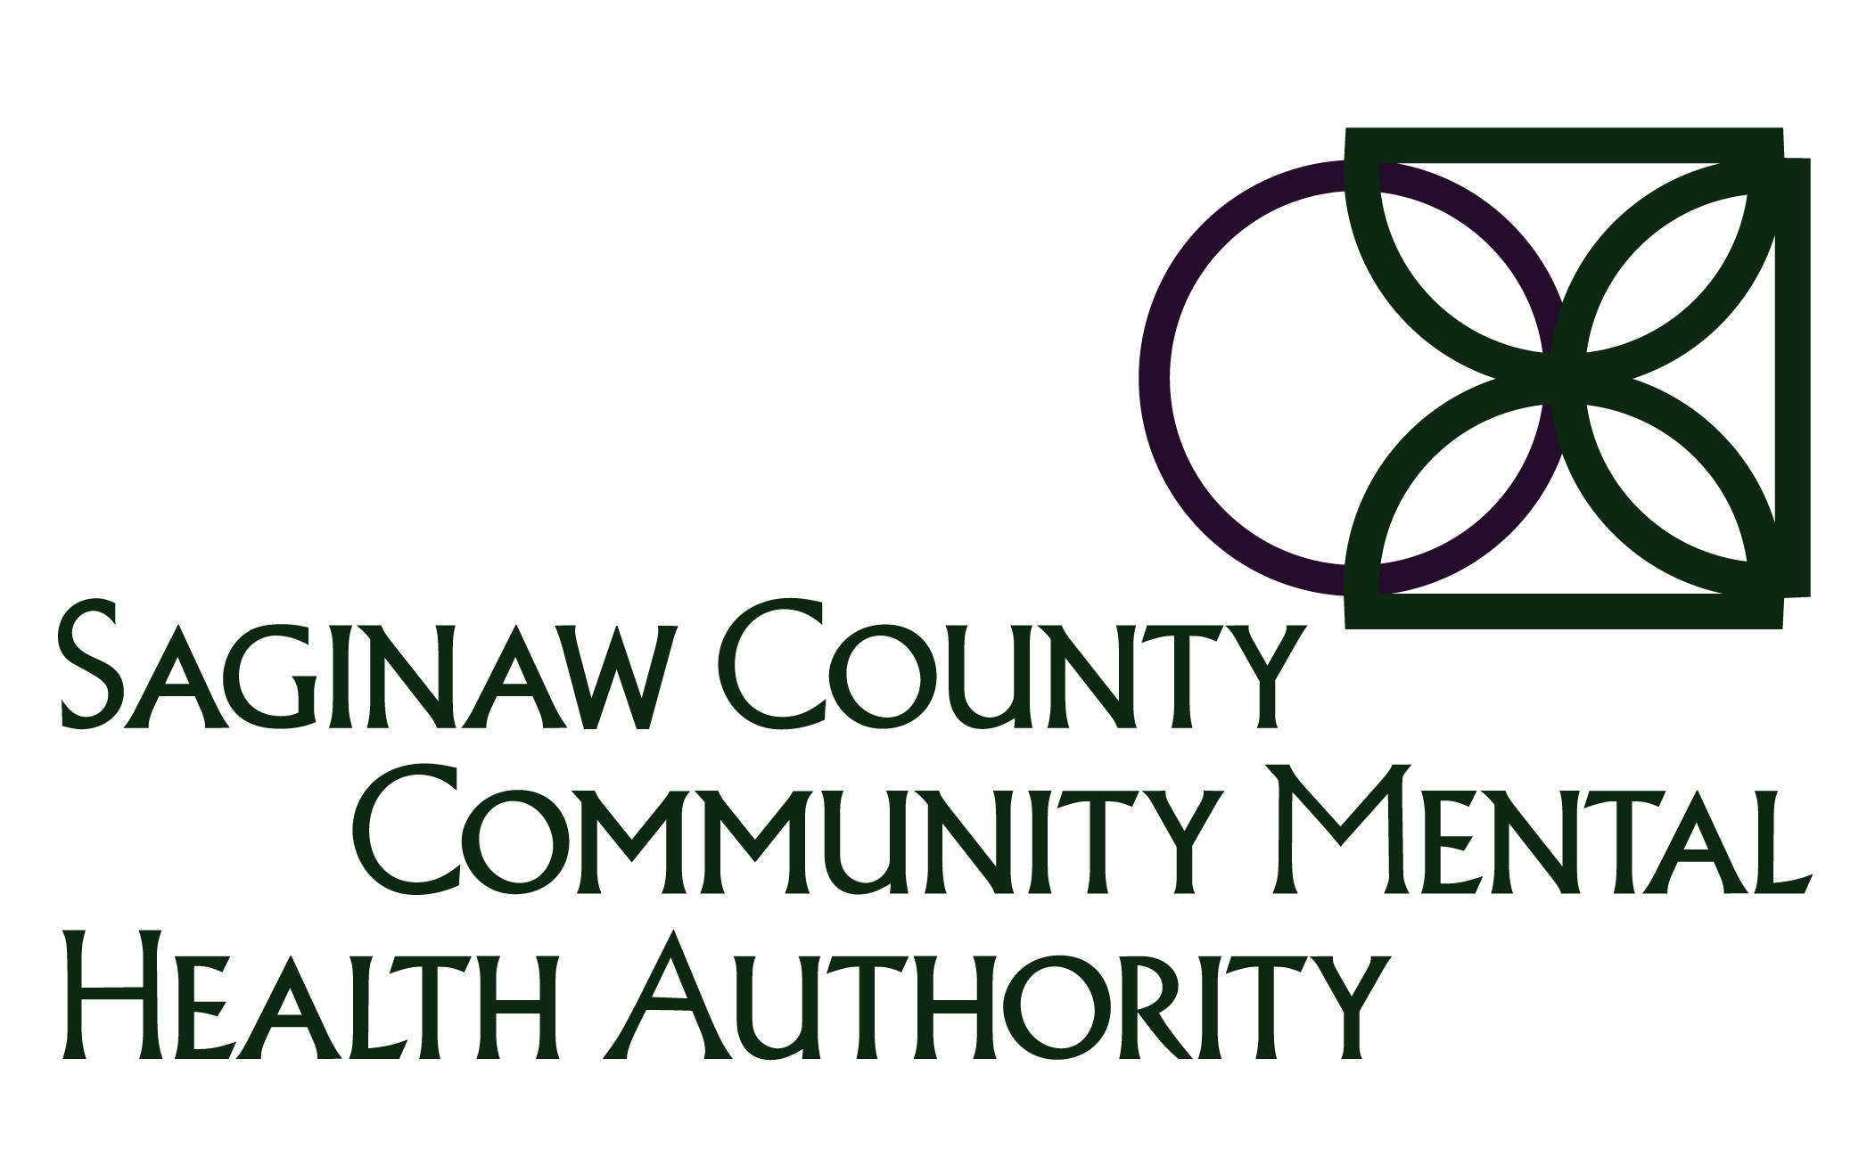

Staff Credentials Certification Form

Staff Name: |  | Supervisor: |  | Date:
CMHP: Individual with specialized training and one year of experience in the examination, evaluation, and treatment of minors and their families and who is a physician, psychologist, licensed or limited-licensed master’s social worker, licensed or limited-licensed professional counselor, licensed or limited-licensed marriage and family therapist or registered nurse; OR an individual with at least a bachelor’s degree in a mental health related field from an accredited school who is trained and has three years supervised experience in the examination, evaluation, and treatment of minors and their families; OR an individual with at least a master’s degree in a mental health-related field from an accredited school who is trained and has one year of experience in the examination, evaluation and treatment of minors and their families. For the BHT/ABA services individuals must be a BCBA or BCaBA or Psychologist working within their scope of practice with extensive knowledge and training on behavior analysis and BCBA certified by 9/30/2020.
 |  | I meet the qualifications for CMHP based on the following:
☐ | I have transferred from another agency where I had CMHP status, or
☐ | I am an individual with specialized training and one year of experience in the examination, evaluation, and treatment of minors and their families and who is a physician, psychologist, licensed or limited-licensed master’s social worker, licensed or limited-licensed professional counselor, licensed or limited-licensed marriage and family therapist or registered nurse.
☐ |  | I am an individual with at least a bachelor’s degree in a mental health related field from an accredited school who is trained and has three years supervised experience in the examination, evaluation, and treatment of minors and their families.
☐ | I am an individual with at least a master’s degree in a mental health-related field from an accredited school who is trained and has one year of experience in the examination, evaluation and treatment of minors and their families. For the BHT/ABA services individuals must be a BCBA or BCaBA or Psychologist working within their scope of practice with extensive knowledge and training on behavior analysis and BCBA certified by 9/30/2020.
QIDP: Individual with specialized training (including fieldwork and/or internships associated with the academic curriculum where the student works directly with persons with intellectual or developmental disabilities as part of that experience) OR one year of experience in treating or working with a person who has intellectual disability; AND is a psychologist, physician, educator with a degree in education from an accredited program, social worker, physical therapist, occupational therapist, speech-language pathologist, audiologist, behavior analyst, registered nurse, registered dietician, therapeutic recreation specialist, a licensed/limited-licensed professional counselor, OR a human services professional with at least a bachelor’s degree in a human services field.
I meet the qualifications for QIDP based on the following:
☐ | I have transferred from another agency where I had QIDP status, or
☐ | I have worked with a person who has an intellectual disability, as noted on my resume or other form of documentation attached to this form, for a year or longer, and
☐ | I am a licensed or limited licensed social worker, psychologist, or human services professional with at least a bachelor’s degree in a human services field.

QMHP: Individual with specialized training (including fieldwork and/or internships associated with the academic curriculum where the student works directly with persons receiving mental health services as part of that experience) OR one year of experience in treating or working with a person who has mental illness; AND is a psychologist, physician, educator with a degree in education from an accredited program, social worker, physical therapist, occupational therapist, speech-language pathologist, audiologist, behavior analyst, registered nurse, therapeutic recreation specialist, licensed/limited-licensed professional counselor, licensed or limited licensed marriage and family therapist, a licensed physician’s assistant, OR a human services professional with at least a bachelor’s degree in a human services field.
I meet the qualifications for QMHP based on the following:
☐ | I have transferred from another agency where I had QMHP status, or
☐ | I have worked with a person who has a mental illness, as noted on my resume or other form of attached documentation, for a year or longer, and
☐ | I am a licensed or limited licensed social worker, psychologist, or a human services professional with at least a bachelor’s degree in a human services field.

- QIDP professionals can perform Supports Coordination services.
- QIDP & QMHP professionals can perform Targeted Case Management services. If Case Manager has only bachelor’s degree without specialized training or experience, they must be supervised by a QMHP or QIDP.

I certify the above information is true and accurate and realize that any false information could cause SCCMHA to not be able to bill for Habilitation Supports Waiver Services and/or Targeted Case Management.

Staff Signature |  | Staff Printed Name |  | Date
Verified by:

 | Staff Signature |  | Staff Printed Name |  | Date

