Policy and Procedure Manual
Saginaw County Community Mental Health Authority
Subject: Recipient Rights – Confidentiality | Chapter: 02 -  Customer Service and Recipient Rights | Subject No: 02.02.05
Effective Date:  March 7, 2000 | Date of Review/Revision:  3/19/03, 1/25/08, 6/29/09, 2/22/10, 6/22/12, 6/13/14, 11/27/16, 6/6/18, 1/8/19, 2/21/20, 2/9/21, 5/10/22, 3/14/23 | Approved By:  Sandra M. Lindsey, CEO  Responsible Director:  Director of  Customer Services, Recipient Rights, & Security  Authored By:  Director of Customer Services, Recipient Rights, & Security  Additional Reviewers:
Effective Date:  March 7, 2000 | Supersedes:  06.02.04.00


Purpose:
The purpose of this Policy is to protect the information in the record of a consumer, and other information acquired in the course of providing public mental health services to a consumer.

Policy:
Information obtained through the course of public mental health treatment shall be kept confidential unless the consumer has signed an Authorization to Release Medical Information or is otherwise specified by law.

Application:
This Policy applies to all Saginaw County Community Mental Health Authority (SCCMHA) direct operated programs as well as all SCCMHA Service Provider Network programs.

Standards:
F1) As stated in the Policy Section, all information in the clinical record and other information obtained in the course of providing services is confidential.

F2) A summary of the Michigan Mental Health Code section 330.1748 is made a part of every consumer record.

F3) For case records made subsequent to March 28, 1996; information made confidential by Section 330.748 of the Michigan Mental Health Code, shall be disclosed to a competent adult consumer upon the consumer’s request. Release will be done as expeditiously as possible, but in no event, later than the earlier of 30 days of the request, or prior to release from treatment.

F4) Except as otherwise provided in 1748 (4), if consent has been obtained from:
- The consumer,
- The consumer’s guardian who has the authority to consent,
- A parent with legal custody of a minor consumer, or
- Court appointed personal representative or executor of the estate of a deceased consumer, information made confidential by 1748 may be disclosed to:
  - a provider of mental health services to the consumer, or
  - the consumer, his or her guardian, the parent of a minor, or another individual or agency unless, in the written judgement of the holder {of the record} the disclosure would be detrimental to the consumer or others.

F5) When requested, information shall be disclosed only under one or more of the
following circumstances:
- Pursuant to order or subpoenas of a court of record or legislature for non-privileged information, unless the information is privileged by law
- To a prosecuting attorney as necessary for the prosecutor to participate in a proceeding governed by Mental Health Code
- To an attorney for the consumer with consent of the consumer, the consumer’s guardian with authority to consent, or the parent with legal and physical custody of a minor consumer
- To the Auditor General
- When necessary in order to comply with another provision of the law
- To MDHHS when information is necessary in order for the department to discharge a responsibility placed upon it by law
- To a surviving spouse, or if none, closest relative of the in order to apply for and receive benefits, but only if the spouse or closest relative has been designated the personal representative or has a court order.

F6) For requests made for confidential information by a person or agnecy not covered under 1748(4) the following steps will be followed.
- The holder of the record shall not decline to disclose information if a consumer or other empowered representative has consented, except for a documented reason.
- If a holder declines to disclose, there shall be a determination whether part of the information can be released without detriment.
- Once the decision has been made to not release information based on deteriment, the CEO will review the information and determine if a part of the information requested may be released without detriment.

F7) This review shall not exceed 3 business days if the record is on-site, or 10 business days if the record is off-site.

F8) The requestor of the information may file a complaint with the SCCMHA ORR if he or she disagrees with the decision of the CEO.

F9) This policy is established in accordance with the Michigan Department of Health and Human Services (MDHHS) ORR CMH Rights System Assessment Policy Review Standards.

F10) Attorneys representing consumers may review records only upon presentation of identification and the consumer’s consent or a release executed by the parent or guardian shall be permitted to review the record on the provider’s premises.

F11) An attorney who has been retained or appointed to represent a minor pursuant to an objection to hospitalization of a minor shall be allowed to review the records.

F12) Attorneys who are not representing consumers may review records only if the attorney presents a certified copy of an order from a court directing disclosure of information concerning the consumer to the attorney.

F13) Attorneys shall be refused information by phone or in writing without the consent or release from the consumer or the request is accompanied or preceded by a certified copy of an order from a court ordering disclosure of information to that attorney.

F14) A private physician or psychologist appointed by the court, or retained for testimony in civil, criminal, or administrative proceedings shall, upon presentation of identification and a certified copy of a court order, be permitted to review the records of the consumer on SCCMHA premesis. Before the review, notification shall be provided to the reviewer and to the court if the records contain privileged communication which cannot be disclosed in court, unless disclosure is permitted because of an express waiver of privilege or because of other conditions that, by law permit or require disclosure.

F15) A prosecutor may be given non-privileged information or privileged information which may be disclosed if it contains information relating to names of witnesses to acts which support the criteria for involuntary admission, information relevant to alternatives, to admission to a hospital or facility and other information designated in policies of SCCMHA.

F16) Information shall be provided as necessary for treatment, coordination of care, or payment for the delivery of mental health services, in accordance with the health insurance portability and accountability act of 1996, Public Law 104-191.

F17) The holder of a record may disclose information that enables a consumer to apply for or receive benefits without the consent of the consumer or legally authorized representative only if the benefits shall accrue to the provider or shall be subject to collection for liability for mental health service.

F18) SCCMHA shall grant a representative of Disability Rights of Michigan access to the records of all of the following:
- A consumer, if the consumer, the consumer’s guardian with authority to consent, or a minor’s parents with physical and legal custody of the consumer, have consented to the access
- A consumer, including a consumer who has died, or whose whereabouts are unknown, if, all of the following apply:
  - Because of a mental or physical condition, the consumer is unable to consent to access
  - The consumer does not have a guardian or other legal representative, or the consumer’s guardian is the State
  - Disability Rights of Michigan has received a complaint on behalf of the consumer, or has probable cause to believe, based on monitoring or other evidence, that the consumer has been subject to abuse or neglect
- A consumer who has a guardian or other legal representative if all of the following apply:
  - A complaint has been received by the protection and advocacy system or there is probable cause to believe the health or safety of the consumer is in serious and immediate jeopardy
  - Upon receipt of the name and address of the consumer’s legal representative, Disability Rights of Michigan has contacted the representative and offered assistance in resolving the situation
  - The representative has failed or refused to act on behalf of the consumer

F19) The records, data, and knowledge collected for or by individuals or committees assigned a peer review function including the review function under section 143a (1) of the Mental Health Code are confidential, are used only for the purpose of peer review, are not public records, and are not subject to court subpoena.

F20) SCCMHA, when authorized to release information for clinical purposes by the consumer, their guardian, or a parent of a minor, releases a copy of the entire medical and clinical record to the provider of mental health services.

F21) Upon reciept of a written request from Department of Health and Human Services and/or Child Protective Services, every effort will be made to provide the requested records or information by the next business day. However, compliance with the request will not exceed 14 days from the receipt of the request.

F22) A consumer, guardian, or parent of a minor consumer, after having gained access to treatment records, may challenge the accuracy, completeness, timeliness, or relevance of factual information in the consumer’s record; the consumer or other empowered representative will be allowed to insert into the record a statement correcting or amending the information at issue; the statement will became part of the record.

F23) A record is kept of disclosures including:
- Information released,
- To whom it is released,
- Purpose stated by person requesting the information,
- Statement indicating how disclosed information is germane to the state purpose,
- The part of law under which disclosure is made,
- Statement that the persons receiving the disclosed information could only further disclose consistent with the authorized purpose for which it was released.

F24) Any person receiving information made confidential by this policy shall disclose the information to others to the extent consistent with the authorized purpose for which the information was released. A record shall be kept of all disclosures including:
- Information released
- To whom it is released
- Purpose stated by the person requesting the information
- Statement indicating how disclosure information is germane to the stated purpose
- The part of law by which disclosure is made
- Statement that the persons receiving the disclosed information could only further disclose consistent with the authorized purpose for which it was released

F25) Information may be disclosed at the discretion of the holder of the record:
- As necessary for the purpose of, outside research, evaluation, accreditation, or statistical compilation, provided that the person who is the subject of the information be identified from the disclosed information, only when such identification is essential in order to achieve the purpose for which the information is sought or when preventing such identification would clearly be impractical. But, in no event when the subject of the information is likely to be harmed by such identification.
- To providers of mental or other health services or a public agency when there is a compelling need for disclosure based upon a substantial probability of harm to the or other person.

F26) Unless 330.748(4) applies, if a request for information has been delayed, the
SCCMHA Chief Executive Officer (CEO) shall review the request.

Definitions:
Holder of the record: The agency given charge over a record which contains confidential information obtained through the course of mental health treatment.

References:
Mental Health Code: 330.1748
Mental Health Code: 330.1749
Mental Health Code: 330.1776
Administrative Rules: 330.7051
45 Code of Federal Regulations 164.502(g)(4)
Health insurance portability and accountability act of 1996
Public Law 104-19

Exhibits:
Exhibit A - Saginaw County Community Mental Health Authority Release of Information

Procedure:
ACTIONS | RESPONSIBLE
- Requests for information contained in consumer medical records are directed to the Medical Records Unit.  - Any individual requesting medical records, including consumers, will be required to sign the appropriate release to receive the requested information.  - Requests for medical records are processed in accordance with the Standards contained in this policy. | - Persons requesting medical records  - Medical Records staff  - Medical Records staff

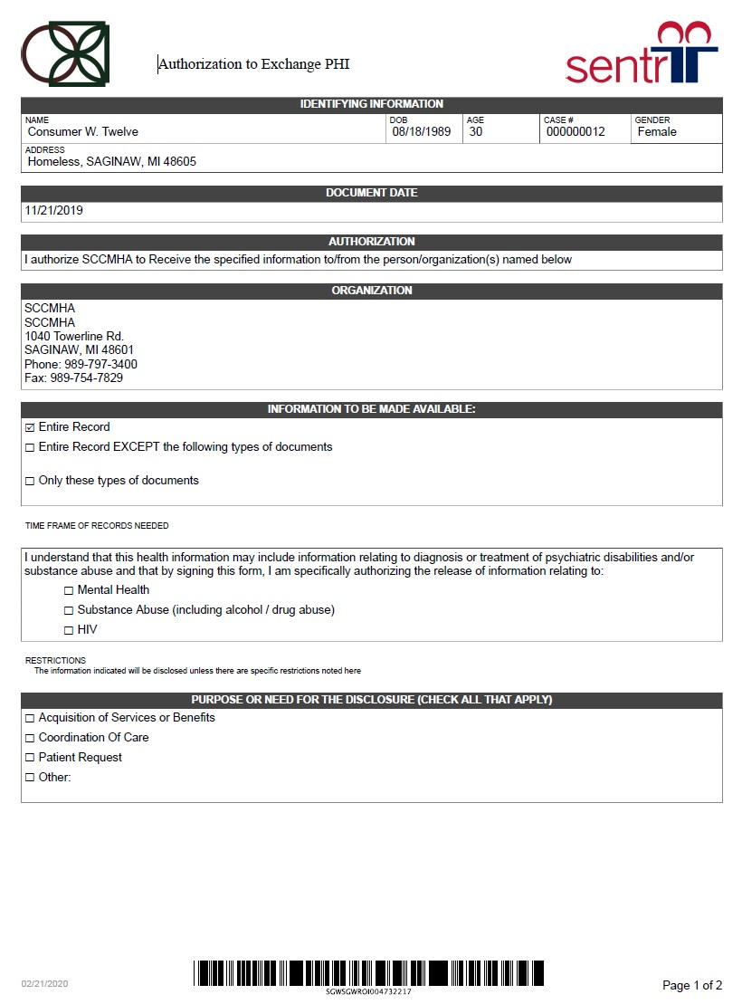
Exhibit A



