Policy and Procedure Manual
Saginaw County Community Mental Health Authority
Subject: Recipient Rights – Voice Recording, Photography, Fingerprinting, and the use of One-Way Glass | Chapter: 02 -  Customer Services and Recipient Rights | Subject No: 02.02.18
Effective Date:  March 7, 2000 | Date of Review/Revision:  2/19/03, 1/25/08, 6/29/09, 6/22/12, 6/14/14, 11/27/16, 6/1/18, 1/8/19, 2/11/20, 2/9/21, 5/10/22, 3/14/23 | Approved By:  Sandra M. Lindsey, CEO  Responsible Director:  Director of  Customer Services, Recipient Rights, & Security  Authored By:  Director of  Customer Services, Recipient Rights, & Security  Additional Reviewers:
Effective Date:  March 7, 2000 | Supersedes:  06.02.21.00


Purpose:
The purpose of this policy is to set limits and guidelines for the use of voice recording, fingerprinting, and the use of one-way glass in the treatment of consumers receiving mental health services from Saginaw County Community Mental Health Authority (SCCMHA) or any of its Service Provider Network.

Policy:
It is the policy of SCCMHA that the use of voice recording, fingerprinting, and one-way glass will not be used without the expressed written consent of the consumer, their guardian, parent of a minor or loco parentis.

Application:
This policy applies to all SCCMHA direct operated programs as well as all Provider Network programs.

Standards:
E1) Fingerprints, photographs, or audiotapes may be taken and one-way glass may be used only when prior expressed written consent is obtained from the consumer, their guardian, parent of a minor or loco parentis.

E2) Fingerprints, photographs, or audiotapes may be taken and one-way glass may be used in order to determine the identification of the consumer as set forth in Procedure #4 below.

E3) Written consent is required for the use of fingerprints, photographs, audiotapes, or one-way glass. This written consent will be obtained from the consumer, their guardian, parent of a minor or loco parentis.

E4) Consent for the use of fingerprints, photographs, audiotapes, or one-way glass may be withdrawn at any time.

E5) Photographs (videos are excluded) may be taken for purely personal or social purposes. However, photographs taken will not be posted on social media or for any public viewing without prior expressed written consent. A photograph of a consumer shall not be taken or used if the consumer has indicated his or her objection.

E6) The safekeeping of fingerprints, photographs, or audiotapes is described in Procedures #3, 4, & 5 below.

E7) Fingerprints, photographs, or audiotapes in the record of a consumer, and any copies of them, shall be given to the consumer, or destroyed when they are no longer essential to achieve one of the objectives set forth in subsection (E2), or upon discharge of the resident, whichever occurs first.

E8) The consent for the use of fingerprints, photographs, audiotapes, or one-way glass will be considered valid for one year from the date of the initial signature. However, the Assigned Support Staff will make known to the consumer, their guardian, parent of a minor or loco parentis each time any of these methods are being used and the consent can be withdrawn at any time as stated in Standard E4.

E9) This policy prohibits video surveillance when recording is occurring and in non-
public areas.

E10) All consumer consents related to fingerprints, photographs, audiotapes, one-way glass, or written information for SCCMHA publications will be completed by using the MDHHS-5515 - Consent to Share Behavioral Health Information link in Sentri II.

Definitions:
Assigned Support Staff: Case Manager, Support Coordinator, or Therapist assigned to work with a SCCMHA consumer. The Case Manager, Support Coordinator, or Therapist may be a SCCMHA staff person or a member of the SCCMHA Service Provider Network.

Loco Parentis: A person or institution that assumes parental rights and duties for a minor.

Photography: Still pictures, motion pictures, and videotapes

Social Media: Social interaction among people in which they create, share or exchange information and ideas in virtual communities and networks.

References:
Administrative Rules 7003
Michigan Mental Health Code 330.1724

Exhibits:
Exhibit A - SCCMHA - Consent to Share Behavioral Health Information

Procedure:
ACTION | RESPONSIBILITY
- The rights of consumers receiving mental health services are clearly protected under the Michigan Mental Health Code in specific regard to fingerprints, photographs, use of one-way glass, and audiotapes. It is the duty of the SCCMHA Recipient Rights Office to ensure these rights are upheld.  - Any use of fingerprints, photographs, audiotapes, or of one-way glass without the expressed written consent of the consumer, (if 18 years of age or over and competent to consent), their guardian, the parent of a minor, or loco parentis is expressly prohibited.  - In the event that fingerprints, photographs, or audiotapes are taken in order to provide services to a consumer, all copies of them shall be kept as part of the record of the consumer.  - If fingerprints, photographs, or audiotapes are necessary for determining the name of a consumer, these will be kept as part of the record. If necessary, the fingerprints, photographs, or audiotapes may be delivered to others for assistance in determining the identity of the consumer. Upon completion of the use of the fingerprints, photographs, or audiotapes, together with copies, will be kept as part of the record of the consumer.  - Fingerprints, photographs, or audiotapes in the record of a consumer, and any copies of them, will be given to the consumer or destroyed when it is no longer essential in order to achieve one of the objectives set forth in standard number E2 of this policy or upon discharge of the consumer, whichever occurs first. | - Recipient Rights Office  - Enforced by the Recipient Rights Office  - Assigned Support Staff  - Assigned Support Staff in conjunction with the Director of the Recipient Rights Office  - Assigned Support Staff in conjunction with their Supervisor and the Medical Records Unit

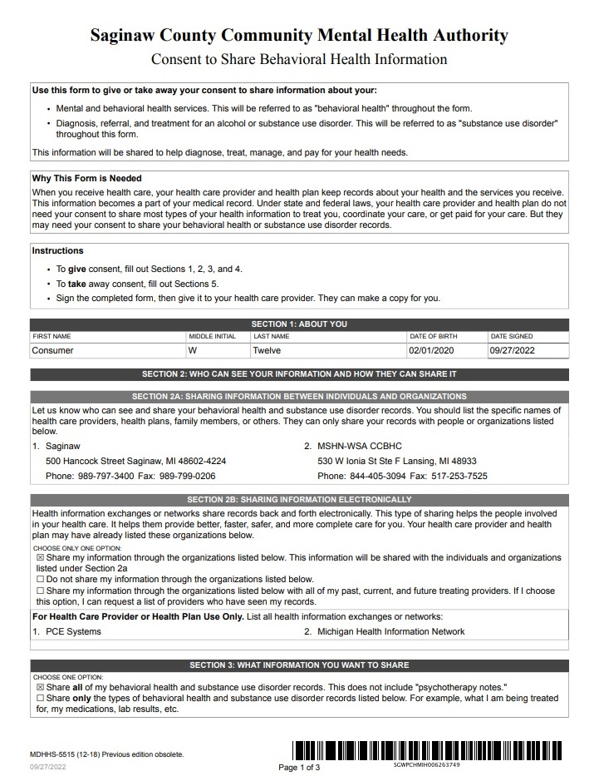
Exhibit A



